Венедиков, Ив. Римска военна диплома от с. Брестовене, Кубратско
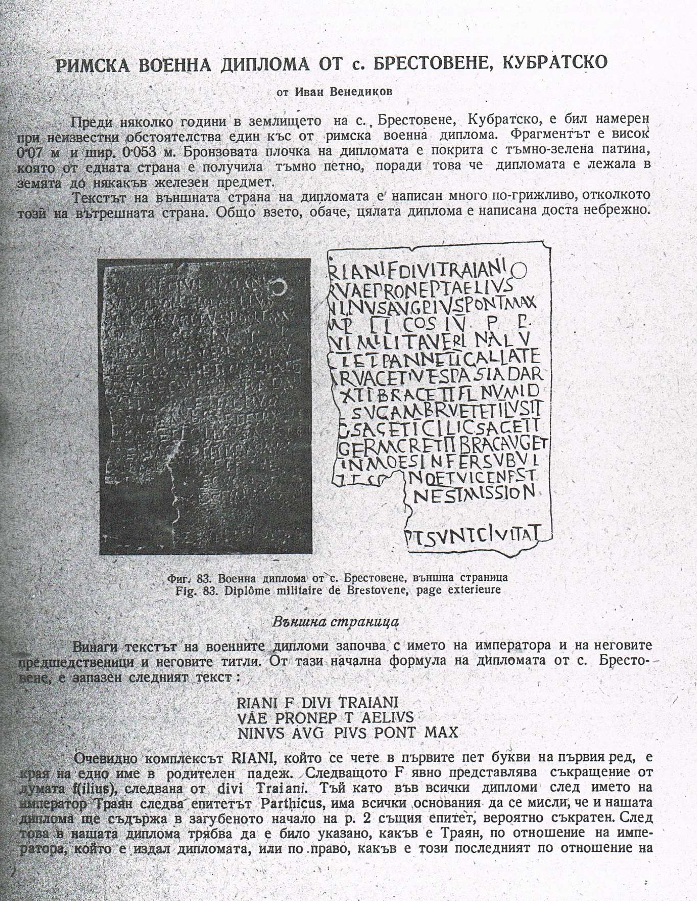

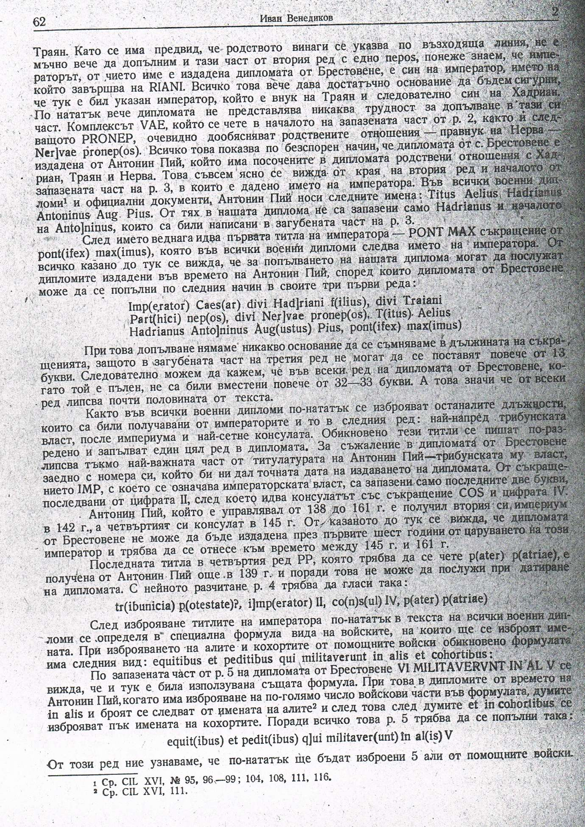

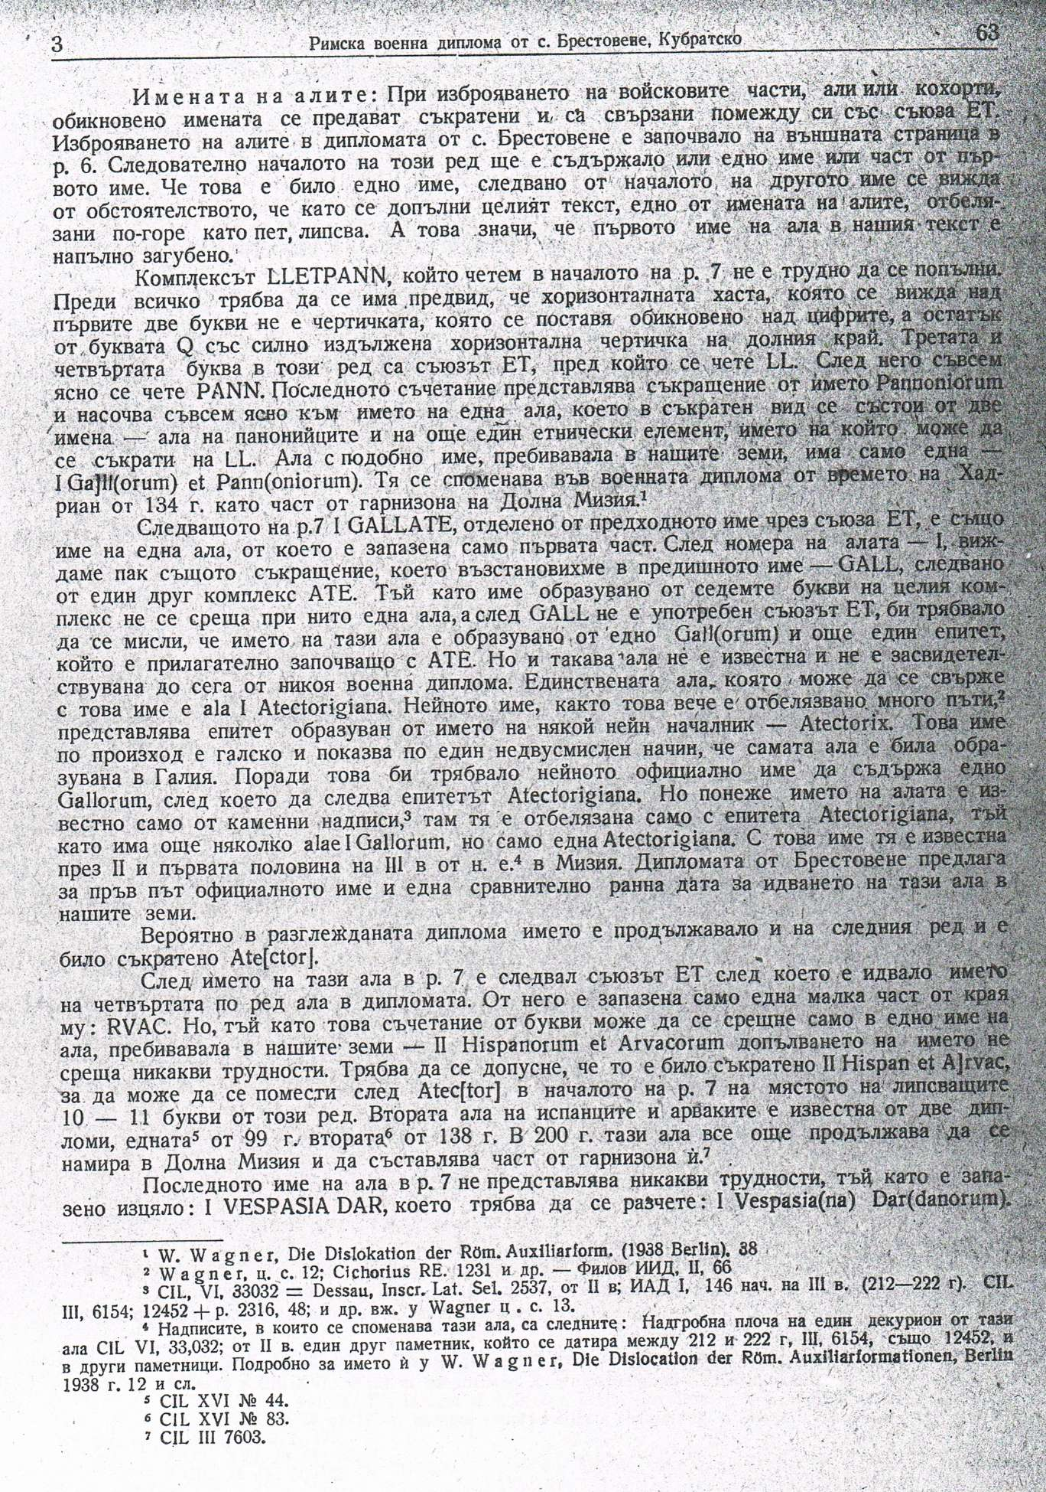

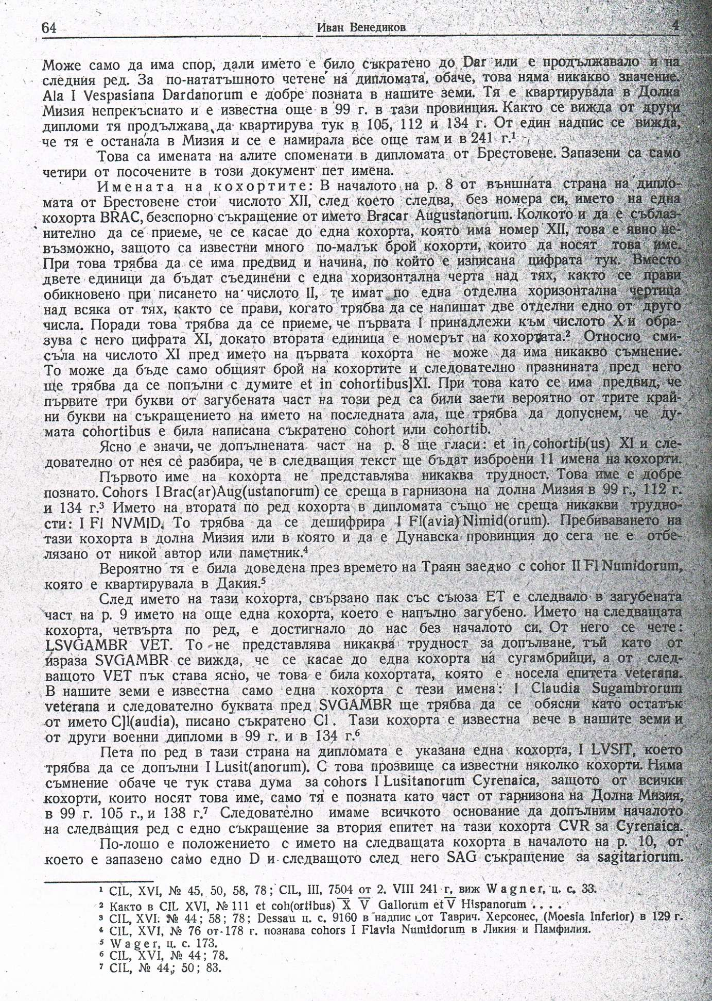

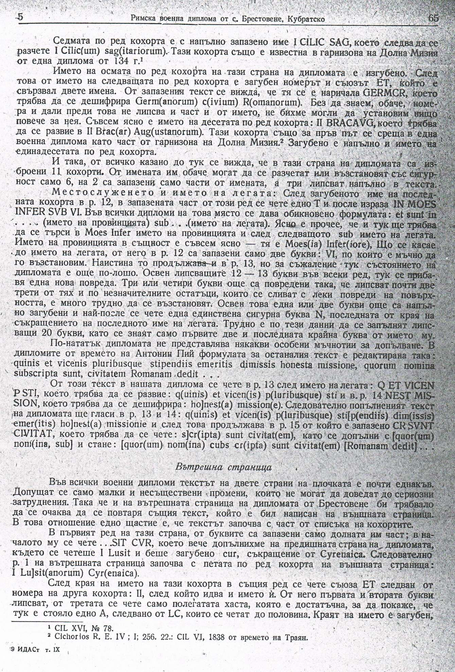

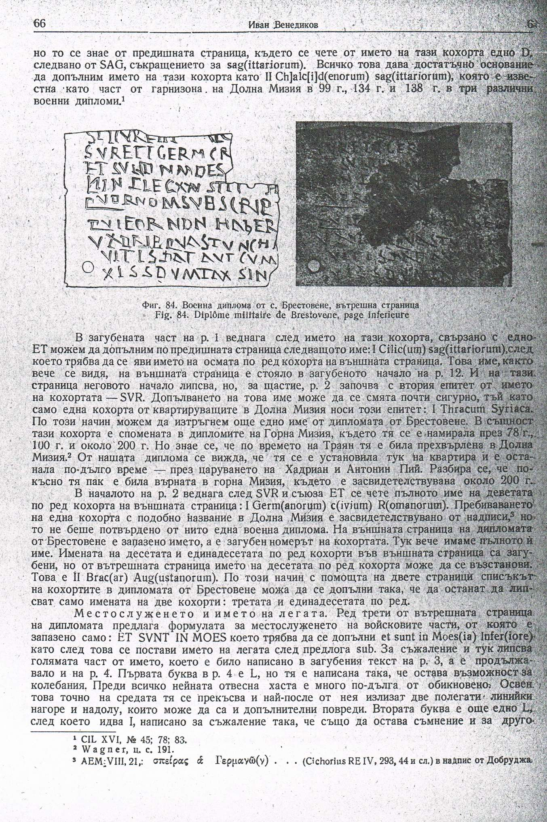

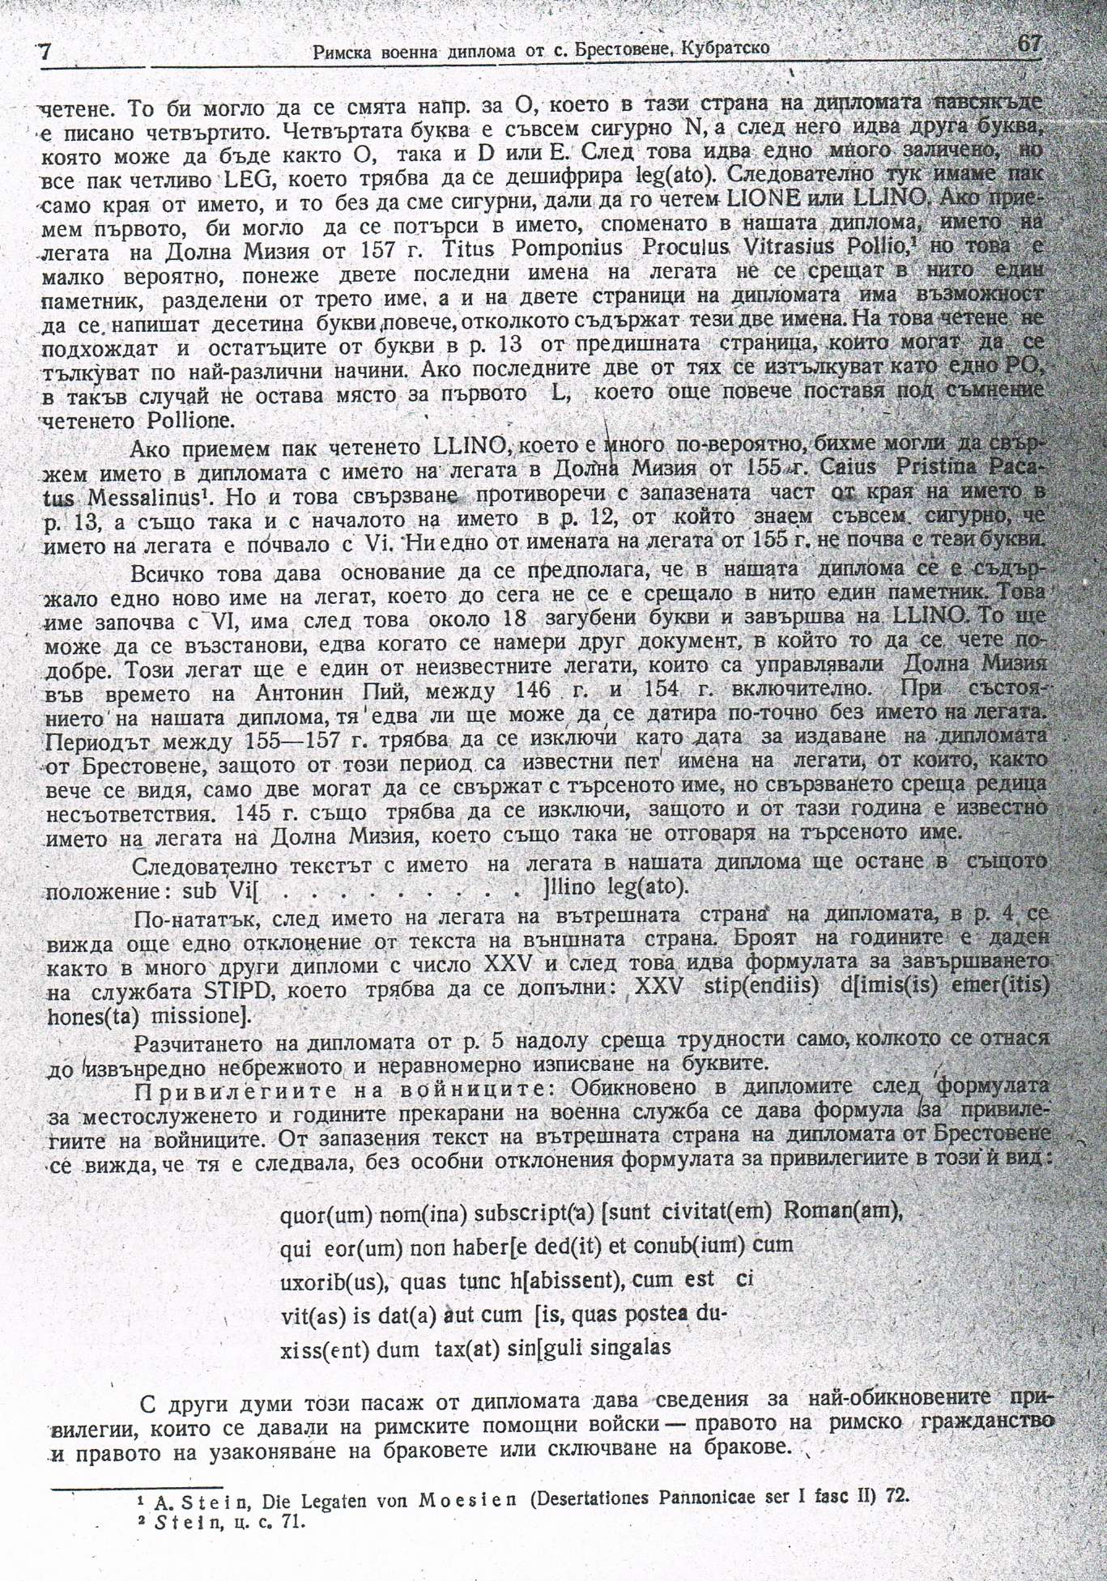

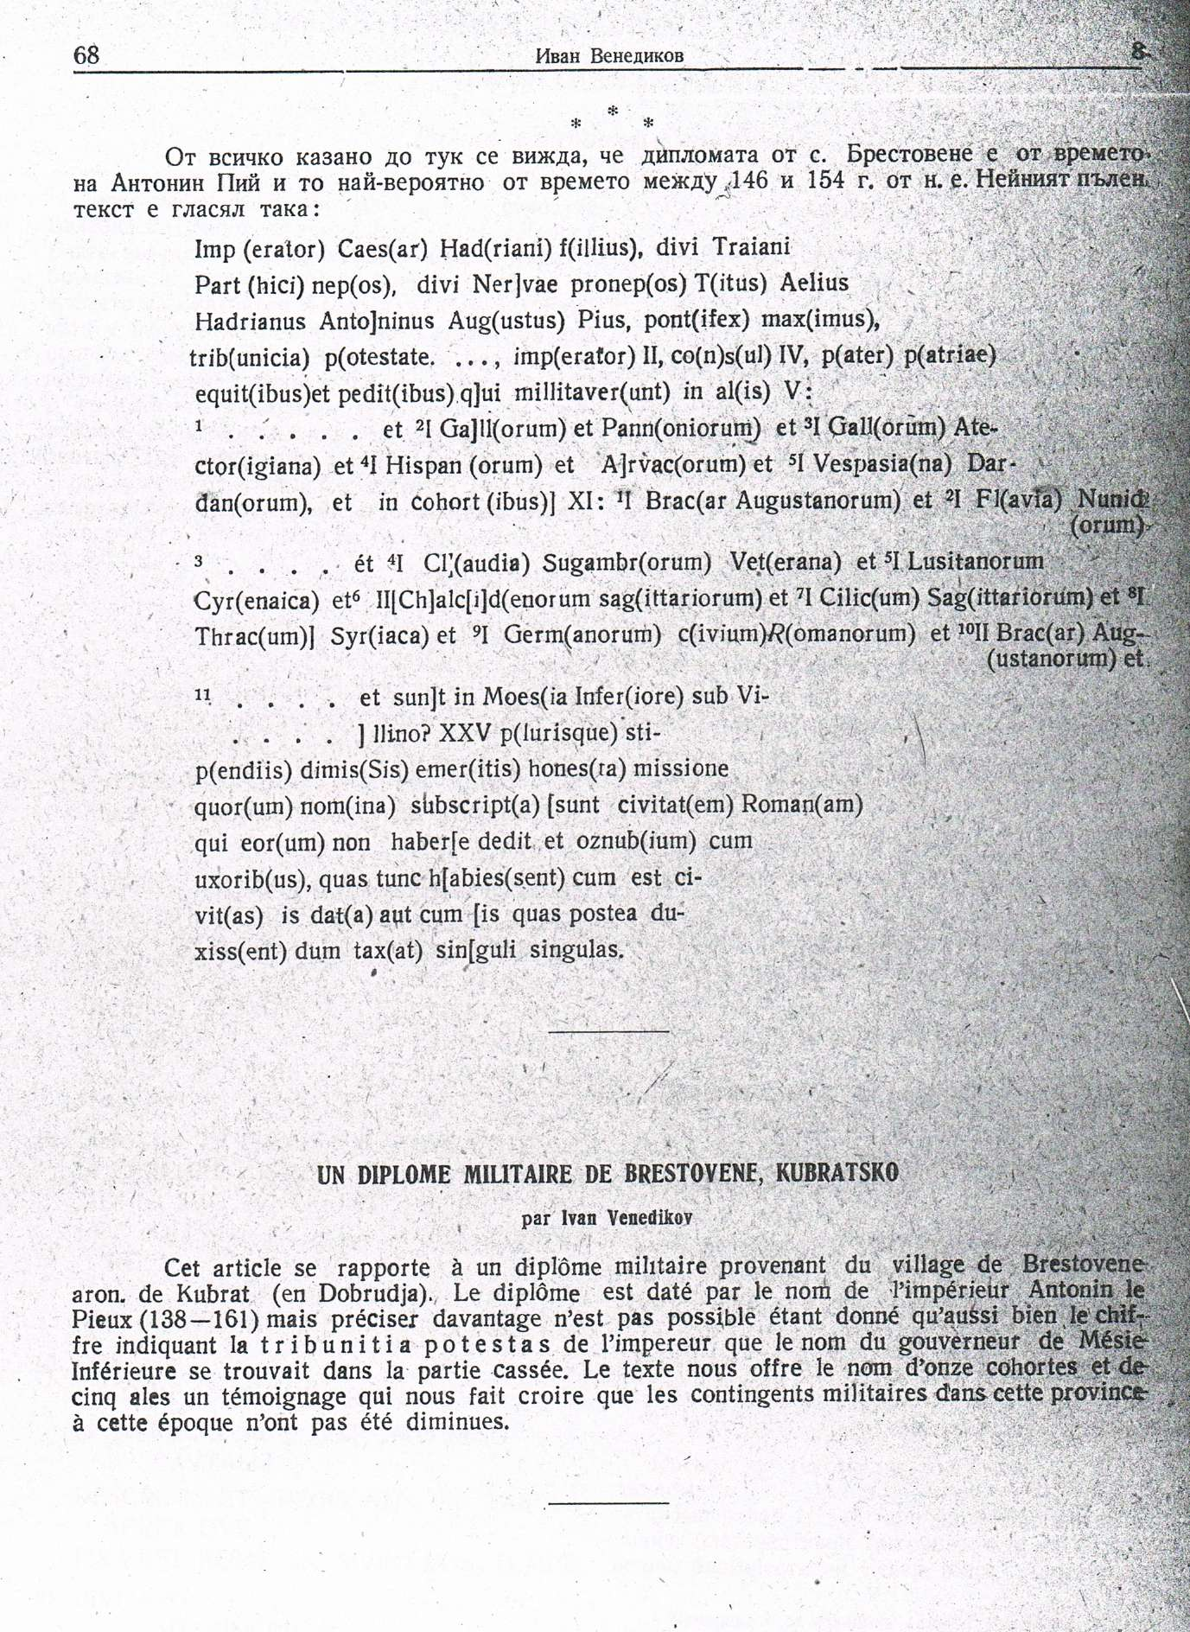

Венедиков, Ив. Римска военна диплома от с. Брестовене, Кубратско. ИВАД, ІХ, 1953, с. 61-68.

INCLUDEPICTURE "http://t0.gstatic.com/images?q=tbn:ANd9GcTDT1jpfS6n_Y4NmsXFnf0dV2uAk854tEHeOSaIXPxUCt7qxHu5xaSaZA" \* MERGEFORMATINET INCLUDEPICTURE "http://t0.gstatic.com/images?q=tbn:ANd9GcTDT1jpfS6n_Y4NmsXFnf0dV2uAk854tEHeOSaIXPxUCt7qxHu5xaSaZA" \* MERGEFORMATINET INCLUDEPICTURE "http://t0.gstatic.com/images?q=tbn:ANd9GcTDT1jpfS6n_Y4NmsXFnf0dV2uAk854tEHeOSaIXPxUCt7qxHu5xaSaZA" \* MERGEFORMATINET INCLUDEPICTURE "http://t0.gstatic.com/images?q=tbn:ANd9GcTDT1jpfS6n_Y4NmsXFnf0dV2uAk854tEHeOSaIXPxUCt7qxHu5xaSaZA" \* MERGEFORMATINET INCLUDEPICTURE "http://t0.gstatic.com/images?q=tbn:ANd9GcTDT1jpfS6n_Y4NmsXFnf0dV2uAk854tEHeOSaIXPxUCt7qxHu5xaSaZA" \* MERGEFORMATINET INCLUDEPICTURE "http://t0.gstatic.com/images?q=tbn:ANd9GcTDT1jpfS6n_Y4NmsXFnf0dV2uAk854tEHeOSaIXPxUCt7qxHu5xaSaZA" \* MERGEFORMATINET INCLUDEPICTURE "http://t0.gstatic.com/images?q=tbn:ANd9GcTDT1jpfS6n_Y4NmsXFnf0dV2uAk854tEHeOSaIXPxUCt7qxHu5xaSaZA" \* MERGEFORMATINET INCLUDEPICTURE "http://t0.gstatic.com/images?q=tbn:ANd9GcTDT1jpfS6n_Y4NmsXFnf0dV2uAk854tEHeOSaIXPxUCt7qxHu5xaSaZA" \* MERGEFORMATINET INCLUDEPICTURE "http://t0.gstatic.com/images?q=tbn:ANd9GcTDT1jpfS6n_Y4NmsXFnf0dV2uAk854tEHeOSaIXPxUCt7qxHu5xaSaZA" \* MERGEFORMATINET INCLUDEPICTURE "http://t0.gstatic.com/images?q=tbn:ANd9GcTDT1jpfS6n_Y4NmsXFnf0dV2uAk854tEHeOSaIXPxUCt7qxHu5xaSaZA" \* MERGEFORMATINET INCLUDEPICTURE "http://t0.gstatic.com/images?q=tbn:ANd9GcTDT1jpfS6n_Y4NmsXFnf0dV2uAk854tEHeOSaIXPxUCt7qxHu5xaSaZA" \* MERGEFORMATINET INCLUDEPICTURE "http://t0.gstatic.com/images?q=tbn:ANd9GcTDT1jpfS6n_Y4NmsXFnf0dV2uAk854tEHeOSaIXPxUCt7qxHu5xaSaZA" \* MERGEFORMATINET INCLUDEPICTURE "http://t0.gstatic.com/images?q=tbn:ANd9GcTDT1jpfS6n_Y4NmsXFnf0dV2uAk854tEHeOSaIXPxUCt7qxHu5xaSaZA" \* MERGEFORMATINET INCLUDEPICTURE "http://t0.gstatic.com/images?q=tbn:ANd9GcTDT1jpfS6n_Y4NmsXFnf0dV2uAk854tEHeOSaIXPxUCt7qxHu5xaSaZA" \* MERGEFORMATINET INCLUDEPICTURE "http://t0.gstatic.com/images?q=tbn:ANd9GcTDT1jpfS6n_Y4NmsXFnf0dV2uAk854tEHeOSaIXPxUCt7qxHu5xaSaZA" \* MERGEFORMATINET INCLUDEPICTURE "http://t0.gstatic.com/images?q=tbn:ANd9GcTDT1jpfS6n_Y4NmsXFnf0dV2uAk854tEHeOSaIXPxUCt7qxHu5xaSaZA" \* MERGEFORMATINET INCLUDEPICTURE "http://t0.gstatic.com/images?q=tbn:ANd9GcTDT1jpfS6n_Y4NmsXFnf0dV2uAk854tEHeOSaIXPxUCt7qxHu5xaSaZA" \* MERGEFORMATINET INCLUDEPICTURE "http://t0.gstatic.com/images?q=tbn:ANd9GcTDT1jpfS6n_Y4NmsXFnf0dV2uAk854tEHeOSaIXPxUCt7qxHu5xaSaZA" \* MERGEFORMATINET INCLUDEPICTURE "http://t0.gstatic.com/images?q=tbn:ANd9GcTDT1jpfS6n_Y4NmsXFnf0dV2uAk854tEHeOSaIXPxUCt7qxHu5xaSaZA" \* MERGEFORMATINET INCLUDEPICTURE "http://t0.gstatic.com/images?q=tbn:ANd9GcTDT1jpfS6n_Y4NmsXFnf0dV2uAk854tEHeOSaIXPxUCt7qxHu5xaSaZA" \* MERGEFORMATINET INCLUDEPICTURE "http://t0.gstatic.com/images?q=tbn:ANd9GcTDT1jpfS6n_Y4NmsXFnf0dV2uAk854tEHeOSaIXPxUCt7qxHu5xaSaZA" \* MERGEFORMATINET INCLUDEPICTURE "http://t0.gstatic.com/images?q=tbn:ANd9GcTDT1jpfS6n_Y4NmsXFnf0dV2uAk854tEHeOSaIXPxUCt7qxHu5xaSaZA" \* MERGEFORMATINET INCLUDEPICTURE "http://t0.gstatic.com/images?q=tbn:ANd9GcTDT1jpfS6n_Y4NmsXFnf0dV2uAk854tEHeOSaIXPxUCt7qxHu5xaSaZA" \* MERGEFORMATINET INCLUDEPICTURE "http://t0.gstatic.com/images?q=tbn:ANd9GcTDT1jpfS6n_Y4NmsXFnf0dV2uAk854tEHeOSaIXPxUCt7qxHu5xaSaZA" \* MERGEFORMATINET INCLUDEPICTURE "http://t0.gstatic.com/images?q=tbn:ANd9GcTDT1jpfS6n_Y4NmsXFnf0dV2uAk854tEHeOSaIXPxUCt7qxHu5xaSaZA" \* MERGEFORMATINET INCLUDEPICTURE "http://t0.gstatic.com/images?q=tbn:ANd9GcTDT1jpfS6n_Y4NmsXFnf0dV2uAk854tEHeOSaIXPxUCt7qxHu5xaSaZA" \* MERGEFORMATINET INCLUDEPICTURE "http://t0.gstatic.com/images?q=tbn:ANd9GcTDT1jpfS6n_Y4NmsXFnf0dV2uAk854tEHeOSaIXPxUCt7qxHu5xaSaZA" \* MERGEFORMATINET INCLUDEPICTURE "http://t0.gstatic.com/images?q=tbn:ANd9GcTDT1jpfS6n_Y4NmsXFnf0dV2uAk854tEHeOSaIXPxUCt7qxHu5xaSaZA" \* MERGEFORMATINET INCLUDEPICTURE "http://t0.gstatic.com/images?q=tbn:ANd9GcTDT1jpfS6n_Y4NmsXFnf0dV2uAk854tEHeOSaIXPxUCt7qxHu5xaSaZA" \* MERGEFORMATINET INCLUDEPICTURE "http://t0.gstatic.com/images?q=tbn:ANd9GcTDT1jpfS6n_Y4NmsXFnf0dV2uAk854tEHeOSaIXPxUCt7qxHu5xaSaZA" \* MERGEFORMATINET INCLUDEPICTURE "http://t0.gstatic.com/images?q=tbn:ANd9GcTDT1jpfS6n_Y4NmsXFnf0dV2uAk854tEHeOSaIXPxUCt7qxHu5xaSaZA" \* MERGEFORMATINET INCLUDEPICTURE "http://t0.gstatic.com/images?q=tbn:ANd9GcTDT1jpfS6n_Y4NmsXFnf0dV2uAk854tEHeOSaIXPxUCt7qxHu5xaSaZA" \* MERGEFORMATINET INCLUDEPICTURE "http://t0.gstatic.com/images?q=tbn:ANd9GcTDT1jpfS6n_Y4NmsXFnf0dV2uAk854tEHeOSaIXPxUCt7qxHu5xaSaZA" \* MERGEFORMATINET INCLUDEPICTURE "http://t0.gstatic.com/images?q=tbn:ANd9GcTDT1jpfS6n_Y4NmsXFnf0dV2uAk854tEHeOSaIXPxUCt7qxHu5xaSaZA" \* MERGEFORMATINET INCLUDEPICTURE "http://t0.gstatic.com/images?q=tbn:ANd9GcTDT1jpfS6n_Y4NmsXFnf0dV2uAk854tEHeOSaIXPxUCt7qxHu5xaSaZA" \* MERGEFORMATINET INCLUDEPICTURE "http://t0.gstatic.com/images?q=tbn:ANd9GcTDT1jpfS6n_Y4NmsXFnf0dV2uAk854tEHeOSaIXPxUCt7qxHu5xaSaZA" \* MERGEFORMATINET INCLUDEPICTURE "http://t0.gstatic.com/images?q=tbn:ANd9GcTDT1jpfS6n_Y4NmsXFnf0dV2uAk854tEHeOSaIXPxUCt7qxHu5xaSaZA" \* MERGEFORMATINET INCLUDEPICTURE "http://t0.gstatic.com/images?q=tbn:ANd9GcTDT1jpfS6n_Y4NmsXFnf0dV2uAk854tEHeOSaIXPxUCt7qxHu5xaSaZA" \* MERGEFORMATINET INCLUDEPICTURE "http://t0.gstatic.com/images?q=tbn:ANd9GcTDT1jpfS6n_Y4NmsXFnf0dV2uAk854tEHeOSaIXPxUCt7qxHu5xaSaZA" \* MERGEFORMATINET INCLUDEPICTURE "http://t0.gstatic.com/images?q=tbn:ANd9GcTDT1jpfS6n_Y4NmsXFnf0dV2uAk854tEHeOSaIXPxUCt7qxHu5xaSaZA" \* MERGEFORMATINET INCLUDEPICTURE "http://t0.gstatic.com/images?q=tbn:ANd9GcTDT1jpfS6n_Y4NmsXFnf0dV2uAk854tEHeOSaIXPxUCt7qxHu5xaSaZA" \* MERGEFORMATINET INCLUDEPICTURE "http://t0.gstatic.com/images?q=tbn:ANd9GcTDT1jpfS6n_Y4NmsXFnf0dV2uAk854tEHeOSaIXPxUCt7qxHu5xaSaZA" \* MERGEFORMATINET INCLUDEPICTURE "http://t0.gstatic.com/images?q=tbn:ANd9GcTDT1jpfS6n_Y4NmsXFnf0dV2uAk854tEHeOSaIXPxUCt7qxHu5xaSaZA" \* MERGEFORMATINET INCLUDEPICTURE "http://t0.gstatic.com/images?q=tbn:ANd9GcTDT1jpfS6n_Y4NmsXFnf0dV2uAk854tEHeOSaIXPxUCt7qxHu5xaSaZA" \* MERGEFORMATINET INCLUDEPICTURE "http://t0.gstatic.com/images?q=tbn:ANd9GcTDT1jpfS6n_Y4NmsXFnf0dV2uAk854tEHeOSaIXPxUCt7qxHu5xaSaZA" \* MERGEFORMATINET INCLUDEPICTURE "http://t0.gstatic.com/images?q=tbn:ANd9GcTDT1jpfS6n_Y4NmsXFnf0dV2uAk854tEHeOSaIXPxUCt7qxHu5xaSaZA" \* MERGEFORMATINET INCLUDEPICTURE "http://t0.gstatic.com/images?q=tbn:ANd9GcTDT1jpfS6n_Y4NmsXFnf0dV2uAk854tEHeOSaIXPxUCt7qxHu5xaSaZA" \* MERGEFORMATINET INCLUDEPICTURE "http://t0.gstatic.com/images?q=tbn:ANd9GcTDT1jpfS6n_Y4NmsXFnf0dV2uAk854tEHeOSaIXPxUCt7qxHu5xaSaZA" \* MERGEFORMATINET INCLUDEPICTURE "http://t0.gstatic.com/images?q=tbn:ANd9GcTDT1jpfS6n_Y4NmsXFnf0dV2uAk854tEHeOSaIXPxUCt7qxHu5xaSaZA" \* MERGEFORMATINET INCLUDEPICTURE "http://t0.gstatic.com/images?q=tbn:ANd9GcTDT1jpfS6n_Y4NmsXFnf0dV2uAk854tEHeOSaIXPxUCt7qxHu5xaSaZA" \* MERGEFORMATINET INCLUDEPICTURE "http://t0.gstatic.com/images?q=tbn:ANd9GcTDT1jpfS6n_Y4NmsXFnf0dV2uAk854tEHeOSaIXPxUCt7qxHu5xaSaZA" \* MERGEFORMATINET INCLUDEPICTURE "http://t0.gstatic.com/images?q=tbn:ANd9GcTDT1jpfS6n_Y4NmsXFnf0dV2uAk854tEHeOSaIXPxUCt7qxHu5xaSaZA" \* MERGEFORMATINET INCLUDEPICTURE "http://t0.gstatic.com/images?q=tbn:ANd9GcTDT1jpfS6n_Y4NmsXFnf0dV2uAk854tEHeOSaIXPxUCt7qxHu5xaSaZA" \* MERGEFORMATINET INCLUDEPICTURE "http://t0.gstatic.com/images?q=tbn:ANd9GcTDT1jpfS6n_Y4NmsXFnf0dV2uAk854tEHeOSaIXPxUCt7qxHu5xaSaZA" \* MERGEFORMATINET INCLUDEPICTURE "http://t0.gstatic.com/images?q=tbn:ANd9GcTDT1jpfS6n_Y4NmsXFnf0dV2uAk854tEHeOSaIXPxUCt7qxHu5xaSaZA" \* MERGEFORMATINET INCLUDEPICTURE "http://t0.gstatic.com/images?q=tbn:ANd9GcTDT1jpfS6n_Y4NmsXFnf0dV2uAk854tEHeOSaIXPxUCt7qxHu5xaSaZA" \* MERGEFORMATINET INCLUDEPICTURE "http://t0.gstatic.com/images?q=tbn:ANd9GcTDT1jpfS6n_Y4NmsXFnf0dV2uAk854tEHeOSaIXPxUCt7qxHu5xaSaZA" \* MERGEFORMATINET INCLUDEPICTURE "http://t0.gstatic.com/images?q=tbn:ANd9GcTDT1jpfS6n_Y4NmsXFnf0dV2uAk854tEHeOSaIXPxUCt7qxHu5xaSaZA" \* MERGEFORMATINET INCLUDEPICTURE "http://t0.gstatic.com/images?q=tbn:ANd9GcTDT1jpfS6n_Y4NmsXFnf0dV2uAk854tEHeOSaIXPxUCt7qxHu5xaSaZA" \* MERGEFORMATINET INCLUDEPICTURE "http://t0.gstatic.com/images?q=tbn:ANd9GcTDT1jpfS6n_Y4NmsXFnf0dV2uAk854tEHeOSaIXPxUCt7qxHu5xaSaZA" \* MERGEFORMATINET INCLUDEPICTURE "http://t0.gstatic.com/images?q=tbn:ANd9GcTDT1jpfS6n_Y4NmsXFnf0dV2uAk854tEHeOSaIXPxUCt7qxHu5xaSaZA" \* MERGEFORMATINET INCLUDEPICTURE "http://t0.gstatic.com/images?q=tbn:ANd9GcTDT1jpfS6n_Y4NmsXFnf0dV2uAk854tEHeOSaIXPxUCt7qxHu5xaSaZA" \* MERGEFORMATINET INCLUDEPICTURE "http://t0.gstatic.com/images?q=tbn:ANd9GcTDT1jpfS6n_Y4NmsXFnf0dV2uAk854tEHeOSaIXPxUCt7qxHu5xaSaZA" \* MERGEFORMATINET INCLUDEPICTURE "http://t0.gstatic.com/images?q=tbn:ANd9GcTDT1jpfS6n_Y4NmsXFnf0dV2uAk854tEHeOSaIXPxUCt7qxHu5xaSaZA" \* MERGEFORMATINET INCLUDEPICTURE "http://t0.gstatic.com/images?q=tbn:ANd9GcTDT1jpfS6n_Y4NmsXFnf0dV2uAk854tEHeOSaIXPxUCt7qxHu5xaSaZA" \* MERGEFORMATINET INCLUDEPICTURE "http://t0.gstatic.com/images?q=tbn:ANd9GcTDT1jpfS6n_Y4NmsXFnf0dV2uAk854tEHeOSaIXPxUCt7qxHu5xaSaZA" \* MERGEFORMATINET INCLUDEPICTURE "http://t0.gstatic.com/images?q=tbn:ANd9GcTDT1jpfS6n_Y4NmsXFnf0dV2uAk854tEHeOSaIXPxUCt7qxHu5xaSaZA" \* MERGEFORMATINET INCLUDEPICTURE "http://t0.gstatic.com/images?q=tbn:ANd9GcTDT1jpfS6n_Y4NmsXFnf0dV2uAk854tEHeOSaIXPxUCt7qxHu5xaSaZA" \* MERGEFORMATINET INCLUDEPICTURE "http://t0.gstatic.com/images?q=tbn:ANd9GcTDT1jpfS6n_Y4NmsXFnf0dV2uAk854tEHeOSaIXPxUCt7qxHu5xaSaZA" \* MERGEFORMATINET INCLUDEPICTURE "http://t0.gstatic.com/images?q=tbn:ANd9GcTDT1jpfS6n_Y4NmsXFnf0dV2uAk854tEHeOSaIXPxUCt7qxHu5xaSaZA" \* MERGEFORMATINET INCLUDEPICTURE "http://t0.gstatic.com/images?q=tbn:ANd9GcTDT1jpfS6n_Y4NmsXFnf0dV2uAk854tEHeOSaIXPxUCt7qxHu5xaSaZA" \* MERGEFORMATINET INCLUDEPICTURE "http://t0.gstatic.com/images?q=tbn:ANd9GcTDT1jpfS6n_Y4NmsXFnf0dV2uAk854tEHeOSaIXPxUCt7qxHu5xaSaZA" \* MERGEFORMATINET INCLUDEPICTURE "http://t0.gstatic.com/images?q=tbn:ANd9GcTDT1jpfS6n_Y4NmsXFnf0dV2uAk854tEHeOSaIXPxUCt7qxHu5xaSaZA" \* MERGEFORMATINET INCLUDEPICTURE "http://t0.gstatic.com/images?q=tbn:ANd9GcTDT1jpfS6n_Y4NmsXFnf0dV2uAk854tEHeOSaIXPxUCt7qxHu5xaSaZA" \* MERGEFORMATINET INCLUDEPICTURE "http://t0.gstatic.com/images?q=tbn:ANd9GcTDT1jpfS6n_Y4NmsXFnf0dV2uAk854tEHeOSaIXPxUCt7qxHu5xaSaZA" \* MERGEFORMATINET INCLUDEPICTURE "http://t0.gstatic.com/images?q=tbn:ANd9GcTDT1jpfS6n_Y4NmsXFnf0dV2uAk854tEHeOSaIXPxUCt7qxHu5xaSaZA" \* MERGEFORMATINET INCLUDEPICTURE "http://t0.gstatic.com/images?q=tbn:ANd9GcTDT1jpfS6n_Y4NmsXFnf0dV2uAk854tEHeOSaIXPxUCt7qxHu5xaSaZA" \* MERGEFORMATINET INCLUDEPICTURE "http://t0.gstatic.com/images?q=tbn:ANd9GcTDT1jpfS6n_Y4NmsXFnf0dV2uAk854tEHeOSaIXPxUCt7qxHu5xaSaZA" \* MERGEFORMATINET INCLUDEPICTURE "http://t0.gstatic.com/images?q=tbn:ANd9GcTDT1jpfS6n_Y4NmsXFnf0dV2uAk854tEHeOSaIXPxUCt7qxHu5xaSaZA" \* MERGEFORMATINET INCLUDEPICTURE "http://t0.gstatic.com/images?q=tbn:ANd9GcTDT1jpfS6n_Y4NmsXFnf0dV2uAk854tEHeOSaIXPxUCt7qxHu5xaSaZA" \* MERGEFORMATINET INCLUDEPICTURE "http://t0.gstatic.com/images?q=tbn:ANd9GcTDT1jpfS6n_Y4NmsXFnf0dV2uAk854tEHeOSaIXPxUCt7qxHu5xaSaZA" \* MERGEFORMATINET INCLUDEPICTURE "http://t0.gstatic.com/images?q=tbn:ANd9GcTDT1jpfS6n_Y4NmsXFnf0dV2uAk854tEHeOSaIXPxUCt7qxHu5xaSaZA" \* MERGEFORMATINET INCLUDEPICTURE "http://t0.gstatic.com/images?q=tbn:ANd9GcTDT1jpfS6n_Y4NmsXFnf0dV2uAk854tEHeOSaIXPxUCt7qxHu5xaSaZA" \* MERGEFORMATINET INCLUDEPICTURE "http://t0.gstatic.com/images?q=tbn:ANd9GcTDT1jpfS6n_Y4NmsXFnf0dV2uAk854tEHeOSaIXPxUCt7qxHu5xaSaZA" \* MERGEFORMATINET INCLUDEPICTURE "http://t0.gstatic.com/images?q=tbn:ANd9GcTDT1jpfS6n_Y4NmsXFnf0dV2uAk854tEHeOSaIXPxUCt7qxHu5xaSaZA" \* MERGEFORMATINET INCLUDEPICTURE "http://t0.gstatic.com/images?q=tbn:ANd9GcTDT1jpfS6n_Y4NmsXFnf0dV2uAk854tEHeOSaIXPxUCt7qxHu5xaSaZA" \* MERGEFORMATINET INCLUDEPICTURE "http://t0.gstatic.com/images?q=tbn:ANd9GcTDT1jpfS6n_Y4NmsXFnf0dV2uAk854tEHeOSaIXPxUCt7qxHu5xaSaZA" \* MERGEFORMATINET INCLUDEPICTURE "http://t0.gstatic.com/images?q=tbn:ANd9GcTDT1jpfS6n_Y4NmsXFnf0dV2uAk854tEHeOSaIXPxUCt7qxHu5xaSaZA" \* MERGEFORMATINET INCLUDEPICTURE "http://t0.gstatic.com/images?q=tbn:ANd9GcTDT1jpfS6n_Y4NmsXFnf0dV2uAk854tEHeOSaIXPxUCt7qxHu5xaSaZA" \* MERGEFORMATINET INCLUDEPICTURE "http://t0.gstatic.com/images?q=tbn:ANd9GcTDT1jpfS6n_Y4NmsXFnf0dV2uAk854tEHeOSaIXPxUCt7qxHu5xaSaZA" \* MERGEFORMATINET INCLUDEPICTURE "http://t0.gstatic.com/images?q=tbn:ANd9GcTDT1jpfS6n_Y4NmsXFnf0dV2uAk854tEHeOSaIXPxUCt7qxHu5xaSaZA" \* MERGEFORMATINET INCLUDEPICTURE "http://t0.gstatic.com/images?q=tbn:ANd9GcTDT1jpfS6n_Y4NmsXFnf0dV2uAk854tEHeOSaIXPxUCt7qxHu5xaSaZA" \* MERGEFORMATINET INCLUDEPICTURE "http://t0.gstatic.com/images?q=tbn:ANd9GcTDT1jpfS6n_Y4NmsXFnf0dV2uAk854tEHeOSaIXPxUCt7qxHu5xaSaZA" \* MERGEFORMATINET INCLUDEPICTURE "http://t0.gstatic.com/images?q=tbn:ANd9GcTDT1jpfS6n_Y4NmsXFnf0dV2uAk854tEHeOSaIXPxUCt7qxHu5xaSaZA" \* MERGEFORMATINET INCLUDEPICTURE "http://t0.gstatic.com/images?q=tbn:ANd9GcTDT1jpfS6n_Y4NmsXFnf0dV2uAk854tEHeOSaIXPxUCt7qxHu5xaSaZA" \* MERGEFORMATINET INCLUDEPICTURE "http://t0.gstatic.com/images?q=tbn:ANd9GcTDT1jpfS6n_Y4NmsXFnf0dV2uAk854tEHeOSaIXPxUCt7qxHu5xaSaZA" \* MERGEFORMATINET INCLUDEPICTURE "http://t0.gstatic.com/images?q=tbn:ANd9GcTDT1jpfS6n_Y4NmsXFnf0dV2uAk854tEHeOSaIXPxUCt7qxHu5xaSaZA" \* MERGEFORMATINET INCLUDEPICTURE "http://t0.gstatic.com/images?q=tbn:ANd9GcTDT1jpfS6n_Y4NmsXFnf0dV2uAk854tEHeOSaIXPxUCt7qxHu5xaSaZA" \* MERGEFORMATINET INCLUDEPICTURE "http://t0.gstatic.com/images?q=tbn:ANd9GcTDT1jpfS6n_Y4NmsXFnf0dV2uAk854tEHeOSaIXPxUCt7qxHu5xaSaZA" \* MERGEFORMATINET INCLUDEPICTURE "http://t0.gstatic.com/images?q=tbn:ANd9GcTDT1jpfS6n_Y4NmsXFnf0dV2uAk854tEHeOSaIXPxUCt7qxHu5xaSaZA" \* MERGEFORMATINET INCLUDEPICTURE "http://t0.gstatic.com/images?q=tbn:ANd9GcTDT1jpfS6n_Y4NmsXFnf0dV2uAk854tEHeOSaIXPxUCt7qxHu5xaSaZA" \* MERGEFORMATINET INCLUDEPICTURE "http://t0.gstatic.com/images?q=tbn:ANd9GcTDT1jpfS6n_Y4NmsXFnf0dV2uAk854tEHeOSaIXPxUCt7qxHu5xaSaZA" \* MERGEFORMATINET INCLUDEPICTURE "http://t0.gstatic.com/images?q=tbn:ANd9GcTDT1jpfS6n_Y4NmsXFnf0dV2uAk854tEHeOSaIXPxUCt7qxHu5xaSaZA" \* MERGEFORMATINET INCLUDEPICTURE "http://t0.gstatic.com/images?q=tbn:ANd9GcTDT1jpfS6n_Y4NmsXFnf0dV2uAk854tEHeOSaIXPxUCt7qxHu5xaSaZA" \* MERGEFORMATINET INCLUDEPICTURE "http://t0.gstatic.com/images?q=tbn:ANd9GcTDT1jpfS6n_Y4NmsXFnf0dV2uAk854tEHeOSaIXPxUCt7qxHu5xaSaZA" \* MERGEFORMATINET INCLUDEPICTURE "http://t0.gstatic.com/images?q=tbn:ANd9GcTDT1jpfS6n_Y4NmsXFnf0dV2uAk854tEHeOSaIXPxUCt7qxHu5xaSaZA" \* MERGEFORMATINET INCLUDEPICTURE "http://t0.gstatic.com/images?q=tbn:ANd9GcTDT1jpfS6n_Y4NmsXFnf0dV2uAk854tEHeOSaIXPxUCt7qxHu5xaSaZA" \* MERGEFORMATINET INCLUDEPICTURE "http://t0.gstatic.com/images?q=tbn:ANd9GcTDT1jpfS6n_Y4NmsXFnf0dV2uAk854tEHeOSaIXPxUCt7qxHu5xaSaZA" \* MERGEFORMATINET INCLUDEPICTURE "http://t0.gstatic.com/images?q=tbn:ANd9GcTDT1jpfS6n_Y4NmsXFnf0dV2uAk854tEHeOSaIXPxUCt7qxHu5xaSaZA" \* MERGEFORMATINET INCLUDEPICTURE "http://t0.gstatic.com/images?q=tbn:ANd9GcTDT1jpfS6n_Y4NmsXFnf0dV2uAk854tEHeOSaIXPxUCt7qxHu5xaSaZA" \* MERGEFORMATINET INCLUDEPICTURE "http://t0.gstatic.com/images?q=tbn:ANd9GcTDT1jpfS6n_Y4NmsXFnf0dV2uAk854tEHeOSaIXPxUCt7qxHu5xaSaZA" \* MERGEFORMATINET INCLUDEPICTURE "http://t0.gstatic.com/images?q=tbn:ANd9GcTDT1jpfS6n_Y4NmsXFnf0dV2uAk854tEHeOSaIXPxUCt7qxHu5xaSaZA" \* MERGEFORMATINET INCLUDEPICTURE "http://t0.gstatic.com/images?q=tbn:ANd9GcTDT1jpfS6n_Y4NmsXFnf0dV2uAk854tEHeOSaIXPxUCt7qxHu5xaSaZA" \* MERGEFORMATINET INCLUDEPICTURE "http://t0.gstatic.com/images?q=tbn:ANd9GcTDT1jpfS6n_Y4NmsXFnf0dV2uAk854tEHeOSaIXPxUCt7qxHu5xaSaZA" \* MERGEFORMATINET INCLUDEPICTURE "http://t0.gstatic.com/images?q=tbn:ANd9GcTDT1jpfS6n_Y4NmsXFnf0dV2uAk854tEHeOSaIXPxUCt7qxHu5xaSaZA" \* MERGEFORMATINET INCLUDEPICTURE "http://t0.gstatic.com/images?q=tbn:ANd9GcTDT1jpfS6n_Y4NmsXFnf0dV2uAk854tEHeOSaIXPxUCt7qxHu5xaSaZA" \* MERGEFORMATINET INCLUDEPICTURE "http://t0.gstatic.com/images?q=tbn:ANd9GcTDT1jpfS6n_Y4NmsXFnf0dV2uAk854tEHeOSaIXPxUCt7qxHu5xaSaZA" \* MERGEFORMATINET INCLUDEPICTURE "http://t0.gstatic.com/images?q=tbn:ANd9GcTDT1jpfS6n_Y4NmsXFnf0dV2uAk854tEHeOSaIXPxUCt7qxHu5xaSaZA" \* MERGEFORMATINET INCLUDEPICTURE "http://t0.gstatic.com/images?q=tbn:ANd9GcTDT1jpfS6n_Y4NmsXFnf0dV2uAk854tEHeOSaIXPxUCt7qxHu5xaSaZA" \* MERGEFORMATINET INCLUDEPICTURE "http://t0.gstatic.com/images?q=tbn:ANd9GcTDT1jpfS6n_Y4NmsXFnf0dV2uAk854tEHeOSaIXPxUCt7qxHu5xaSaZA" \* MERGEFORMATINET INCLUDEPICTURE "http://t0.gstatic.com/images?q=tbn:ANd9GcTDT1jpfS6n_Y4NmsXFnf0dV2uAk854tEHeOSaIXPxUCt7qxHu5xaSaZA" \* MERGEFORMATINET INCLUDEPICTURE "http://t0.gstatic.com/images?q=tbn:ANd9GcTDT1jpfS6n_Y4NmsXFnf0dV2uAk854tEHeOSaIXPxUCt7qxHu5xaSaZA" \* MERGEFORMATINET INCLUDEPICTURE "http://t0.gstatic.com/images?q=tbn:ANd9GcTDT1jpfS6n_Y4NmsXFnf0dV2uAk854tEHeOSaIXPxUCt7qxHu5xaSaZA" \* MERGEFORMATINET INCLUDEPICTURE "http://t0.gstatic.com/images?q=tbn:ANd9GcTDT1jpfS6n_Y4NmsXFnf0dV2uAk854tEHeOSaIXPxUCt7qxHu5xaSaZA" \* MERGEFORMATINET INCLUDEPICTURE "http://t0.gstatic.com/images?q=tbn:ANd9GcTDT1jpfS6n_Y4NmsXFnf0dV2uAk854tEHeOSaIXPxUCt7qxHu5xaSaZA" \* MERGEFORMATINET INCLUDEPICTURE "http://t0.gstatic.com/images?q=tbn:ANd9GcTDT1jpfS6n_Y4NmsXFnf0dV2uAk854tEHeOSaIXPxUCt7qxHu5xaSaZA" \* MERGEFORMATINET INCLUDEPICTURE "http://t0.gstatic.com/images?q=tbn:ANd9GcTDT1jpfS6n_Y4NmsXFnf0dV2uAk854tEHeOSaIXPxUCt7qxHu5xaSaZA" \* MERGEFORMATINET INCLUDEPICTURE "http://t0.gstatic.com/images?q=tbn:ANd9GcTDT1jpfS6n_Y4NmsXFnf0dV2uAk854tEHeOSaIXPxUCt7qxHu5xaSaZA" \* MERGEFORMATINET INCLUDEPICTURE "http://t0.gstatic.com/images?q=tbn:ANd9GcTDT1jpfS6n_Y4NmsXFnf0dV2uAk854tEHeOSaIXPxUCt7qxHu5xaSaZA" \* MERGEFORMATINET INCLUDEPICTURE "http://t0.gstatic.com/images?q=tbn:ANd9GcTDT1jpfS6n_Y4NmsXFnf0dV2uAk854tEHeOSaIXPxUCt7qxHu5xaSaZA" \* MERGEFORMATINET INCLUDEPICTURE "http://t0.gstatic.com/images?q=tbn:ANd9GcTDT1jpfS6n_Y4NmsXFnf0dV2uAk854tEHeOSaIXPxUCt7qxHu5xaSaZA" \* MERGEFORMATINET INCLUDEPICTURE "http://t0.gstatic.com/images?q=tbn:ANd9GcTDT1jpfS6n_Y4NmsXFnf0dV2uAk854tEHeOSaIXPxUCt7qxHu5xaSaZA" \* MERGEFORMATINET INCLUDEPICTURE "http://t0.gstatic.com/images?q=tbn:ANd9GcTDT1jpfS6n_Y4NmsXFnf0dV2uAk854tEHeOSaIXPxUCt7qxHu5xaSaZA" \* MERGEFORMATINET INCLUDEPICTURE "http://t0.gstatic.com/images?q=tbn:ANd9GcTDT1jpfS6n_Y4NmsXFnf0dV2uAk854tEHeOSaIXPxUCt7qxHu5xaSaZA" \* MERGEFORMATINET INCLUDEPICTURE "http://t0.gstatic.com/images?q=tbn:ANd9GcTDT1jpfS6n_Y4NmsXFnf0dV2uAk854tEHeOSaIXPxUCt7qxHu5xaSaZA" \* MERGEFORMATINET INCLUDEPICTURE "http://t0.gstatic.com/images?q=tbn:ANd9GcTDT1jpfS6n_Y4NmsXFnf0dV2uAk854tEHeOSaIXPxUCt7qxHu5xaSaZA" \* MERGEFORMATINET INCLUDEPICTURE "http://t0.gstatic.com/images?q=tbn:ANd9GcTDT1jpfS6n_Y4NmsXFnf0dV2uAk854tEHeOSaIXPxUCt7qxHu5xaSaZA" \* MERGEFORMATINET INCLUDEPICTURE "http://t0.gstatic.com/images?q=tbn:ANd9GcTDT1jpfS6n_Y4NmsXFnf0dV2uAk854tEHeOSaIXPxUCt7qxHu5xaSaZA" \* MERGEFORMATINET INCLUDEPICTURE "http://t0.gstatic.com/images?q=tbn:ANd9GcTDT1jpfS6n_Y4NmsXFnf0dV2uAk854tEHeOSaIXPxUCt7qxHu5xaSaZA" \* MERGEFORMATINET INCLUDEPICTURE "http://t0.gstatic.com/images?q=tbn:ANd9GcTDT1jpfS6n_Y4NmsXFnf0dV2uAk854tEHeOSaIXPxUCt7qxHu5xaSaZA" \* MERGEFORMATINET INCLUDEPICTURE "http://t0.gstatic.com/images?q=tbn:ANd9GcTDT1jpfS6n_Y4NmsXFnf0dV2uAk854tEHeOSaIXPxUCt7qxHu5xaSaZA" \* MERGEFORMATINET INCLUDEPICTURE "http://t0.gstatic.com/images?q=tbn:ANd9GcTDT1jpfS6n_Y4NmsXFnf0dV2uAk854tEHeOSaIXPxUCt7qxHu5xaSaZA" \* MERGEFORMATINET INCLUDEPICTURE "http://t0.gstatic.com/images?q=tbn:ANd9GcTDT1jpfS6n_Y4NmsXFnf0dV2uAk854tEHeOSaIXPxUCt7qxHu5xaSaZA" \* MERGEFORMATINET INCLUDEPICTURE "http://t0.gstatic.com/images?q=tbn:ANd9GcTDT1jpfS6n_Y4NmsXFnf0dV2uAk854tEHeOSaIXPxUCt7qxHu5xaSaZA" \* MERGEFORMATINET INCLUDEPICTURE "http://t0.gstatic.com/images?q=tbn:ANd9GcTDT1jpfS6n_Y4NmsXFnf0dV2uAk854tEHeOSaIXPxUCt7qxHu5xaSaZA" \* MERGEFORMATINET INCLUDEPICTURE "http://t0.gstatic.com/images?q=tbn:ANd9GcTDT1jpfS6n_Y4NmsXFnf0dV2uAk854tEHeOSaIXPxUCt7qxHu5xaSaZA" \* MERGEFORMATINET INCLUDEPICTURE "http://t0.gstatic.com/images?q=tbn:ANd9GcTDT1jpfS6n_Y4NmsXFnf0dV2uAk854tEHeOSaIXPxUCt7qxHu5xaSaZA" \* MERGEFORMATINET INCLUDEPICTURE "http://t0.gstatic.com/images?q=tbn:ANd9GcTDT1jpfS6n_Y4NmsXFnf0dV2uAk854tEHeOSaIXPxUCt7qxHu5xaSaZA" \* MERGEFORMATINET INCLUDEPICTURE "http://t0.gstatic.com/images?q=tbn:ANd9GcTDT1jpfS6n_Y4NmsXFnf0dV2uAk854tEHeOSaIXPxUCt7qxHu5xaSaZA" \* MERGEFORMATINET INCLUDEPICTURE "http://t0.gstatic.com/images?q=tbn:ANd9GcTDT1jpfS6n_Y4NmsXFnf0dV2uAk854tEHeOSaIXPxUCt7qxHu5xaSaZA" \* MERGEFORMATINET INCLUDEPICTURE "http://t0.gstatic.com/images?q=tbn:ANd9GcTDT1jpfS6n_Y4NmsXFnf0dV2uAk854tEHeOSaIXPxUCt7qxHu5xaSaZA" \* MERGEFORMATINET INCLUDEPICTURE "http://t0.gstatic.com/images?q=tbn:ANd9GcTDT1jpfS6n_Y4NmsXFnf0dV2uAk854tEHeOSaIXPxUCt7qxHu5xaSaZA" \* MERGEFORMATINET INCLUDEPICTURE "http://t0.gstatic.com/images?q=tbn:ANd9GcTDT1jpfS6n_Y4NmsXFnf0dV2uAk854tEHeOSaIXPxUCt7qxHu5xaSaZA" \* MERGEFORMATINET INCLUDEPICTURE "http://t0.gstatic.com/images?q=tbn:ANd9GcTDT1jpfS6n_Y4NmsXFnf0dV2uAk854tEHeOSaIXPxUCt7qxHu5xaSaZA" \* MERGEFORMATINET INCLUDEPICTURE "http://t0.gstatic.com/images?q=tbn:ANd9GcTDT1jpfS6n_Y4NmsXFnf0dV2uAk854tEHeOSaIXPxUCt7qxHu5xaSaZA" \* MERGEFORMATINET INCLUDEPICTURE "http://t0.gstatic.com/images?q=tbn:ANd9GcTDT1jpfS6n_Y4NmsXFnf0dV2uAk854tEHeOSaIXPxUCt7qxHu5xaSaZA" \* MERGEFORMATINET INCLUDEPICTURE "http://t0.gstatic.com/images?q=tbn:ANd9GcTDT1jpfS6n_Y4NmsXFnf0dV2uAk854tEHeOSaIXPxUCt7qxHu5xaSaZA" \* MERGEFORMATINET INCLUDEPICTURE "http://t0.gstatic.com/images?q=tbn:ANd9GcTDT1jpfS6n_Y4NmsXFnf0dV2uAk854tEHeOSaIXPxUCt7qxHu5xaSaZA" \* MERGEFORMATINET INCLUDEPICTURE "http://t0.gstatic.com/images?q=tbn:ANd9GcTDT1jpfS6n_Y4NmsXFnf0dV2uAk854tEHeOSaIXPxUCt7qxHu5xaSaZA" \* MERGEFORMATINET INCLUDEPICTURE "http://t0.gstatic.com/images?q=tbn:ANd9GcTDT1jpfS6n_Y4NmsXFnf0dV2uAk854tEHeOSaIXPxUCt7qxHu5xaSaZA" \* MERGEFORMATINET
Compiler FLN

